1. Problem Statement
Develop a C++ program to represent campus buildings and pathways as an undirected graph using an adjacency list. Apply Breadth-First Search (BFS) and Depth-First Search (DFS) from a user-selected starting building to examine campus connectivity. Display the BFS and DFS traversal orders, count the number of buildings reachable from the selected building, and identify isolated buildings that have no connecting pathways.

2. Objectives
- Represent campus buildings as vertices and pathways as edges in a graph.
- Use an adjacency list to store connections between buildings.
- Implement BFS and DFS traversal from a selected starting building.
- Display the traversal order produced by both algorithms.
- Count the buildings reachable from the selected starting building.
- Identify isolated buildings that have no connecting pathways.
- Understand how graph algorithms can be used to analyze campus connectivity.

3. Theory
A graph is a non-linear data structure consisting of vertices and edges. In this project, each campus building is a vertex and each pathway is an edge. The graph is undirected because a pathway is treated as connecting the two buildings in both directions.
An adjacency list stores, for each building, a list of directly connected buildings. It is memory-efficient for sparse graphs and makes it convenient to examine a building's neighbors.
Breadth-First Search (BFS) visits vertices level by level using a queue. Depth-First Search (DFS) explores one branch as far as possible before backtracking, commonly using recursion or a stack. Both algorithms can identify all vertices reachable from a start vertex.
An isolated building is a vertex with degree zero, meaning its adjacency list contains no neighboring buildings. A building may have connections but still be unreachable from the chosen start if it belongs to a separate connected component.

4. Algorithms

Step 1: Start the program.

Step 2: Read the number of campus buildings and their names.

Step 3: Initialize an adjacency list to represent the campus graph.
Step 4: Read the number of pathways and the indices of the two buildings connected by each pathway.
Step 5: Add each pathway to the adjacency list in both directions.
Step 6: Read the starting building index.
Step 7: Display the initial campus graph.
Step 8: Perform BFS from the starting building and display the traversal order and number of reachable buildings.
Step 9: Perform DFS from the starting building and display the traversal order and number of reachable buildings.
Step 10: Display all buildings unreachable from the starting building and identify isolated buildings.

Step 11: Ask the user whether a new building should be added.

Step 12: If yes, read the building name and add the new building to the graph. Otherwise, continue.

Step 13: Ask the user whether a new pathway should be added.

Step 14: If yes, read the two building indices, validate them, and add the pathway. Otherwise, continue.

Step 15: Display the updated campus graph.

Step 16: Perform BFS and DFS again from the same starting building.

Step 17: Compare the traversal results and the number of reachable buildings before and after the update.

Step 18: Display whether campus connectivity has improved.

Step 19: Display the updated list of unreachable and isolated buildings.

Step 20: Read the source and destination building indices to check path availability.

Step 21: Use BFS to determine whether a path exists between the two buildings.

Step 22: Display an appropriate message: “Path exists,” “No path exists,” or “Invalid building index.”

Step 23: Stop the program.

4. Flowchart
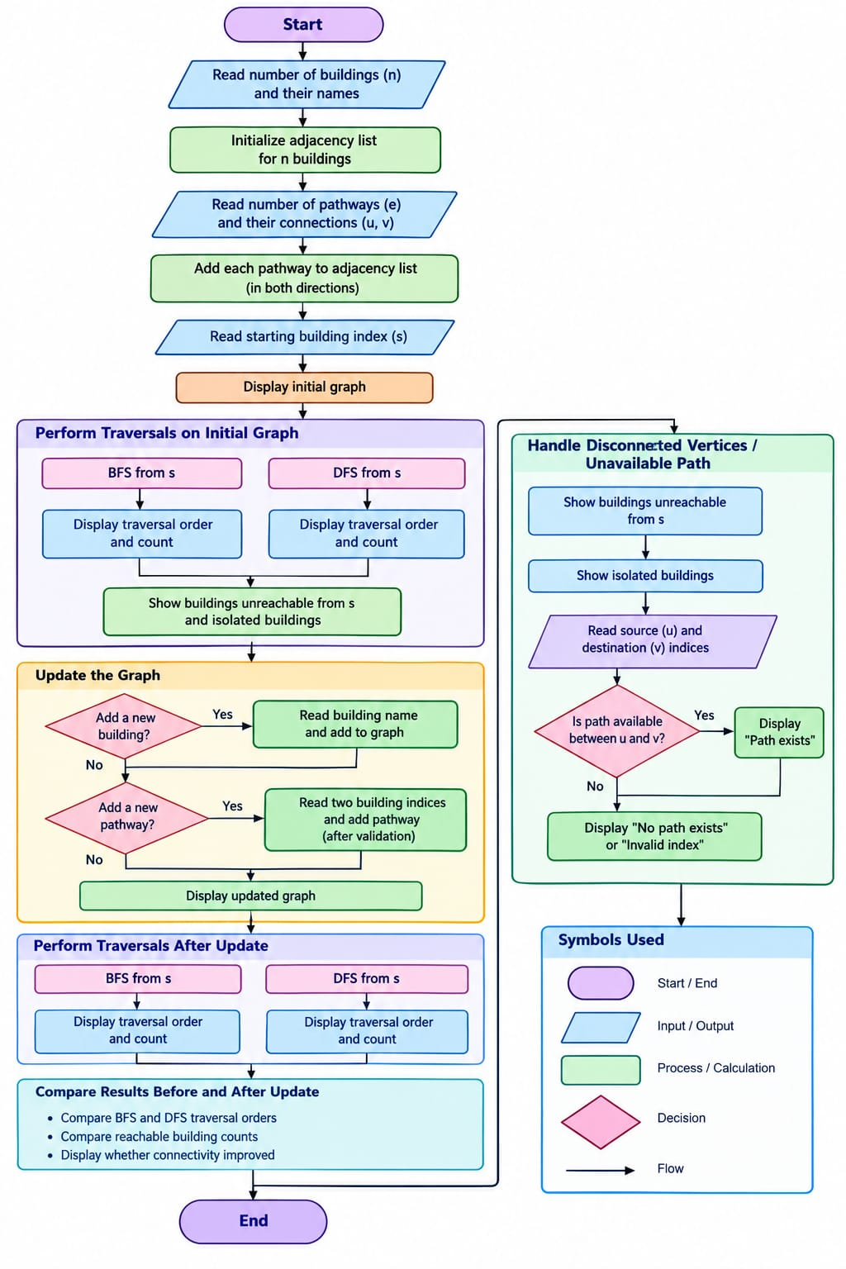

5. C++ Source Code
#include <iostream>
#include <vector>
#include <qu
eue>
#include <string>
using namespace std;
class CampusGraph {
int n;
vector<string> buildings;
vector<vector<int>> adj;
public:
CampusGraph(int size) : n(size), buildings(size), adj(size) {}
void setBuildings() {
cout << "Enter building names (use one word per name):\n";
for (int i = 0; i < n; i++) {
cout << "Building " << i << ": ";
cin >> buildings[i];
}
}
void addPath(int u, int v) {
adj[u].push_back(v);
adj[v].push_back(u);
}
void BFS(int start) {
vector<bool> visited(n, false);
queue<int> q;
visited[start] = true;
q.push(start);
cout << "\nBFS Traversal: ";
while (!q.empty()) {
int u = q.front();
q.pop();
cout << buildings[u] << " ";
for (int v : adj[u]) {
if (!visited[v]) {
visited[v] = true;
q.push(v);
}
}
}
cout << '\n';
}
void DFSUtil(int u, vector<bool>& visited) {
visited[u] = true;
cout << buildings[u] << " ";
for (int v : adj[u]) {
if (!visited[v])
DFSUtil(v, visited);
}
}
void DFS(int start) {
vector<bool> visited(n, false);
cout << "DFS Traversal: ";
DFSUtil(start, visited);
cout << '\n';
}
int countReached(int start) {
vector<bool> visited(n, false);
queue<int> q;
int count = 0;
visited[start] = true;
q.push(start);
while (!q.empty()) {
int u = q.front();
q.pop();
count++;
for (int v : adj[u]) {
if (!visited[v]) {
visited[v] = true;
q.push(v);
}
}
}
return count;
}
void findIsolated() {
cout << "Isolated buildings: ";
bool found = false;
for (int i = 0; i < n; i++) {
if (adj[i].empty()) {
cout << buildings[i] << " ";
found = true;
}
}
if (!found) cout << "None";
cout << '\n';
}
};
int main() {
int n, m;
cout << "Enter number of buildings: ";
cin >> n;
if (n <= 0) {
cout << "Invalid number of buildings.\n";
return 0;
}
CampusGraph campus(n);
campus.setBuildings();
cout << "Enter number of pathways: ";
cin >> m;
if (m < 0) {
cout << "Invalid number of pathways.\n";
return 0;
}
cout << "Enter pathway connections (building indices):\n";
for (int i = 0; i < m; i++) {
int u, v;
cin >> u >> v;
if (u < 0 || u >= n || v < 0 || v >= n) {
cout << "Invalid building index.\n";
return 0;
}
campus.addPath(u, v);
}
int start;
cout << "Enter starting building index: ";
cin >> start;
if (start < 0 || start >= n) {
cout << "Invalid starting building index.\n";
return 0;
}
campus.BFS(start);
campus.DFS(start);
cout << "Buildings reachable from the starting building: "
<< campus.countReached(start) << '\n';
campus.findIsolated();
return 0;
}

6. Sample Input
5
Library
Canteen
Hostel
Lab
Auditorium
3
0 1
1 2
2 3
0

7. Output

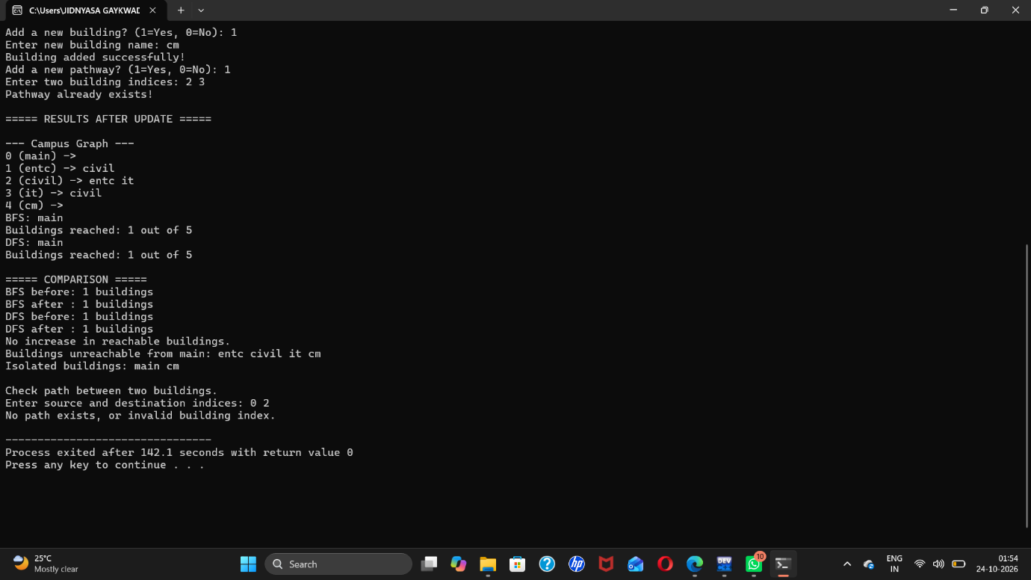
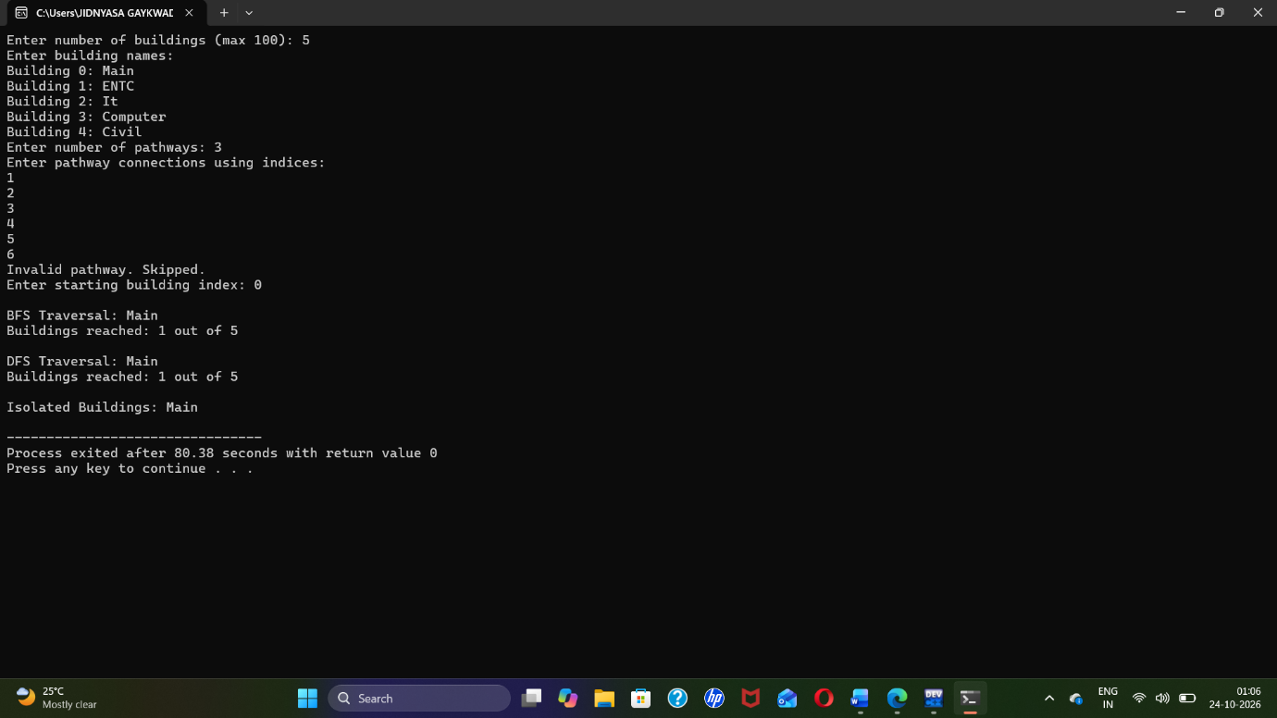

8. Explanation of Output
Starting from Library (index 0), BFS visits the directly connected Canteen, then Hostel, and then Lab. DFS produces the same order for this particular graph because the connections form a simple chain and the adjacency lists are inserted in that order. Four buildings are reachable from Library. Auditorium has no pathway, so it is identified as isolated.

9. Flowchart
Start → Input buildings and pathways → Build the adjacency list → Input starting building → Perform BFS and display traversal → Perform DFS and display traversal → Count reachable buildings → Check each adjacency list for isolated buildings → Display results → End.
For a handwritten or drawn flowchart, use ovals for Start/End, parallelograms for input/output, rectangles for processing, diamonds for decisions, and arrows to show control flow.

10. Time and Space Complexity
Let V be the number of buildings and E be the number of pathways. With an adjacency list, BFS takes O(V + E) time and DFS takes O(V + E) time in the worst case. Counting reachable buildings using BFS also takes O(V + E) time. Identifying isolated buildings takes O(V) time. The graph representation requires O(V + E) space.

11. Applications
- Checking which campus buildings can be reached from a selected building.
- Planning campus walking routes and connectivity.
- Detecting buildings that have no recorded pathway connections.
- Understanding network connectivity in maps, computer networks, and transportation systems.

12. Conclusion
The C++ program represents campus buildings and pathways using an undirected graph and an adjacency list. BFS and DFS are used to traverse the graph from a selected building and display the traversal orders. The program also counts reachable buildings and identifies isolated buildings with no connecting pathways. This demonstrates how graph traversal algorithms can be used to analyze

